Customer Shopping Behavior Analysis

## Project Objective
This project explores how customers actually behave while shopping on an e-commerce platform.
Using data from 3,900 customers, the analysis focuses on understanding:

- How much customers spend and what influences their spending
- Which products and categories drive the most revenue
- Whether discounts, subscriptions, and shipping choices affect purchase behaviour
- Patterns that differentiate one type of customer from another

## Dataset Summary
Rows: 3,900
Columns: 18
Key Features: - Customer demographics (Age, Gender, Location, Subscription Status)
Purchase details (Item Purchased, Category, Purchase Amount, Season, Size, Color)
Shopping behavior (Discount Applied, Promo Code Used, Previous Purchases, Frequency of Purchases, Review Rating, Shipping Type)
Missing Data: 40 values in Review Rating column

## Exploratory Data Analysis using Python
We began with data preparation and cleaning in Python:
- Data Loading: Imported the dataset using pandas.
- Initial Exploration: Used df.info() to check structure and .describe() for summary statistics.
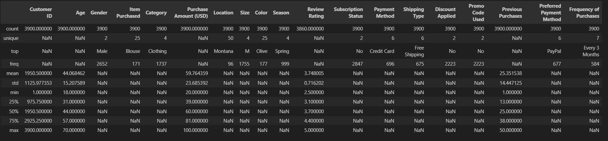

## Duplicate Value Check
The dataset was checked for duplicate records to ensure data integrity.
Duplicate rows can distort analysis results by overrepresenting certain observations.
No duplicates were found.

## Handling Missing Values in Review Rating

The `Review Rating` column contains missing values. A common approach is to replace missing values using the mean or median.
However, using a **single overall median** for all missing values would introduce bias into the dataset.

### Why overall median is a bad idea
Review ratings vary significantly across product categories. For example:
- Clothing items may generally receive different ratings compared to footwear
- Customer expectations differ by category

If we apply one global median, we incorrectly force:
- Clothing items to inherit ratings influenced by footwear
- Footwear items to inherit ratings influenced by clothing

This distorts category-level patterns and reduces the reliability of the analysis.

### Chosen Approach: Category-wise Median Imputation
To preserve realistic rating behaviour, missing values are imputed using the **median review rating within each product category**.

- If a clothing item is missing a rating, it is replaced with the median rating of clothing items
- If a footwear item is missing a rating, it is replaced with the median rating of footwear items

### Why this approach is better
- Median is robust to outliers
- Preserves category-specific customer behaviour
- Minimizes bias introduced during imputation
- Maintains the integrity of downstream analysis

This approach ensures that missing values are filled in a way that reflects actual customer rating patterns rather than forcing artificial uniformity across categories.

## Column Standardization

Column names were converted to snake_case to improve readability, maintain naming consistency, and align with Python and pandas best practices.

## Creating Age Groups
A new column, `age_group`, was created to segment customers into meaningful age categories:
- Young Adult
- Adult
- Middle Age
- Senior
This transformation helps simplify analysis, improves interpretability, and allows customer behaviour to be compared across different life stages rather than individual ages.

Why pd.qcut Is Important
pd.qcut is used to divide a numerical variable into quantile-based groups, meaning each group contains approximately the same number of observations.
pd.qcut creates balanced, data-driven age groups by dividing customers into equal-sized segments, enabling fair comparison across age categories.

## Converting Purchase Frequency to Numerical Format
The purchase frequency column contains text values with overlapping meanings
(e.g., Fortnightly and Bi-Weekly, Quarterly and Every 3 Months).
To enable meaningful analysis, these values were standardized and converted into
`purchase_frequency_days`, representing the approximate number of days between purchases.
This approach removes ambiguity, preserves behavioural intent, and makes customer
frequency comparable across the dataset.

## Redundancy Check: discount_applied vs promo_code_used
Although discounts can theoretically be applied without promo codes
(e.g., seasonal or member-exclusive offers), the dataset was validated
to confirm whether this distinction actually exists.
Cross-tabulation and row-wise comparison show that:
- Every time a promo code was used, a discount was applied
- No discounts exist without a promo code
- Both columns match exactly for all 3,900 records
Since the columns are 100% identical, one of them is redundant and does
not add additional business value. To maintain a clean and efficient
dataset, only one column is retained for further analysis.

## Visualization Theme
A consistent visualization theme is applied across the entire project to
ensure clarity, readability, and professional presentation.
- Neutral light background for reduced visual strain
- Dark gridlines and text for high contrast
- A unified `GnBu` color palette for all charts
This approach maintains visual consistency across analyses and keeps the
focus on insights rather than decorative styling.

## Total Revenue by Gender
Total revenue was calculated by summing purchase amounts for each gender.
This analysis helps identify how revenue contribution differs between
male and female customers.
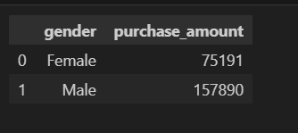
A bar chart is used as it provides a clear and direct comparison of
aggregated revenue across categorical groups.
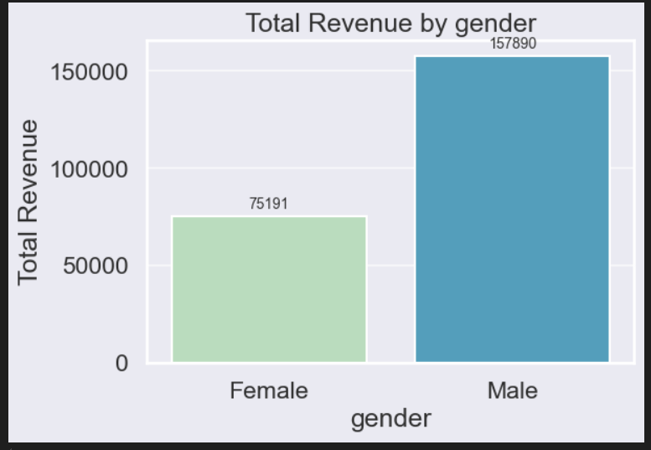

## Customers Using Discounts but Spending Above Average

This analysis identifies customers who used a discount but still spent more than the overall average purchase amount.
These customers represent high-value buyers who are less sensitive to price reductions.
Understanding this group helps businesses design targeted loyalty programs instead of relying on broad discounts.

A box plot is used to highlight the spread and central tendency without focusing on individual customers.
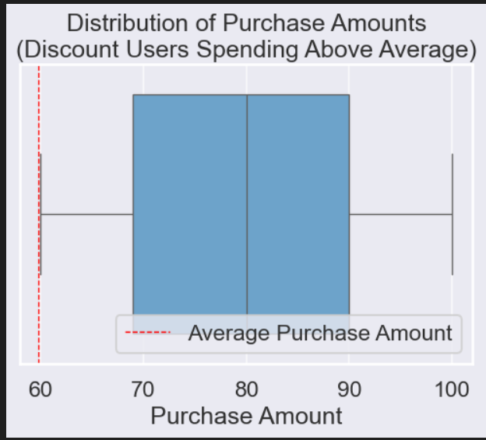

“This chart shows how much customers spent after using discounts, but only for those who still spent above the average purchase amount.
Even with discounts applied, most of these customers consistently spend well above the average, not just in isolated cases.
This tells us discounts are not reducing revenue here — they are encouraging larger basket sizes.
These customers are ideal candidates for loyalty rewards and personalized offers rather than broad discounts.”
“A box plot is suitable here because it clearly shows the spending distribution of many customers, helping us understand whether higher spending among discount users is consistent or driven by a few outliers.”
Business Recommendation
- Shift from flat discounts to loyalty rewards and bundles
- Use discounts to increase basket size, not reduce price
- Prioritize this segment for upselling and cross-selling

## Top 5 Products with the Highest Average Review Rating
This analysis identifies the top 5 products with the highest average customer review ratings.
Average ratings are calculated for each product to understand overall customer satisfaction.
Focusing on the top-rated products helps businesses identify items with strong customer approval.
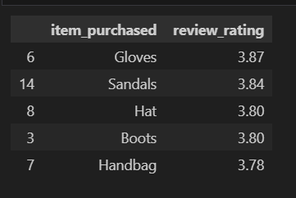

A Horizontal bar chart is used to clearly compare average ratings across products.
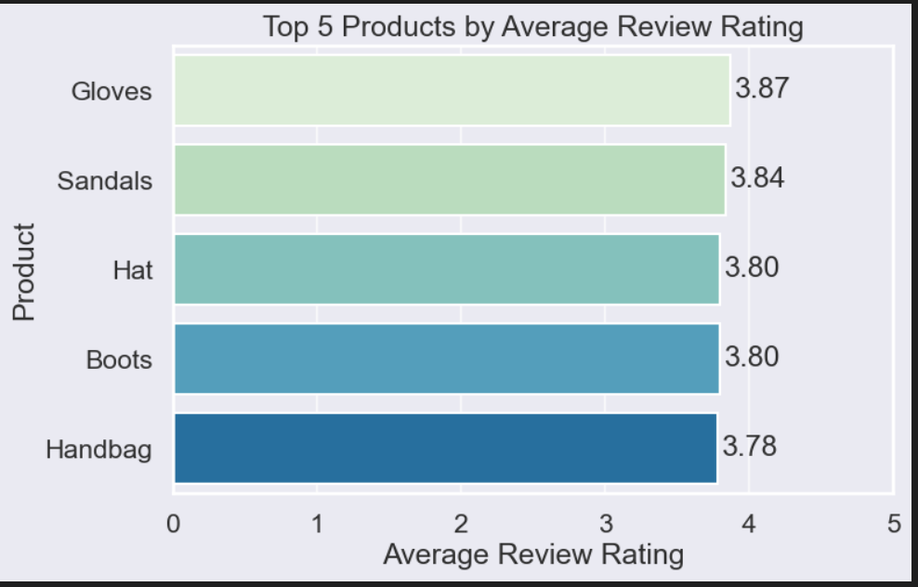

“This chart shows the top five products based on average customer review ratings.
These products consistently receive higher ratings, indicating strong customer satisfaction and product quality.
They represent reliable performers in our catalog and can be prioritized for promotions and visibility.
Improving visibility of these products can help increase customer trust and conversion rates.”
Key Business Insight
“Top-rated products reflect strong customer satisfaction and should be prioritized for promotion and retention strategies.”
- Use them as benchmark products to improve lower-rated items.
- Highlight these products in: Homepage banners, Recommendation sections, Marketing campaigns

## Average Purchase Amount by Shipping Type
The average purchase amount was calculated for customers using Standard and
Express shipping to understand whether faster delivery is associated with
higher customer spending.
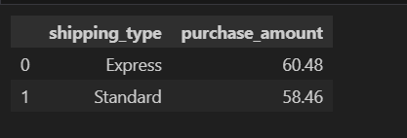
A bar chart is used to clearly compare the average purchase value across
shipping types.
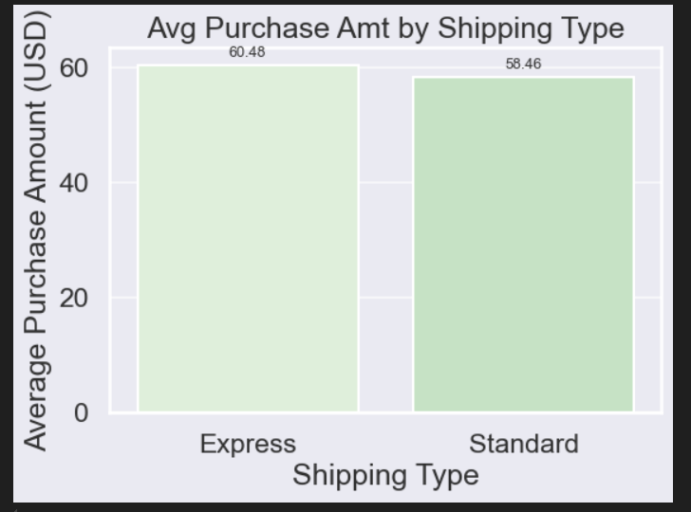

This chart compares the average purchase amount between Standard and Express shipping customers. Customers choosing Express Shipping have a higher average purchase value than those using Standard Shipping. This suggests that customers who prioritize faster delivery may be less price-sensitive or purchasing higher-value items. Shipping preference can therefore act as a proxy for customer value.

Business Insights
- Express Shipping customers generate a higher average order value compared to Standard Shipping customers.
- Faster delivery options appear to attract or retain higher-spending customers.
- Promoting Express Shipping for premium or high-margin products could increase overall revenue.
- Further analysis should validate whether this difference is driven by product category, customer segment, or purchase frequency.
“Customers who opt for Express Shipping show higher average purchase values, indicating a strong opportunity to target premium customers through faster delivery options.”

## Average Spend by Subscription Status
A horizontal bar chart is used to compare the average purchase amount between
subscribed and non-subscribed customers.
This orientation improves readability and makes small differences in average spend easier to interpret.
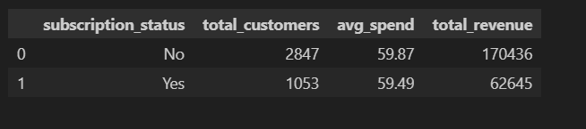
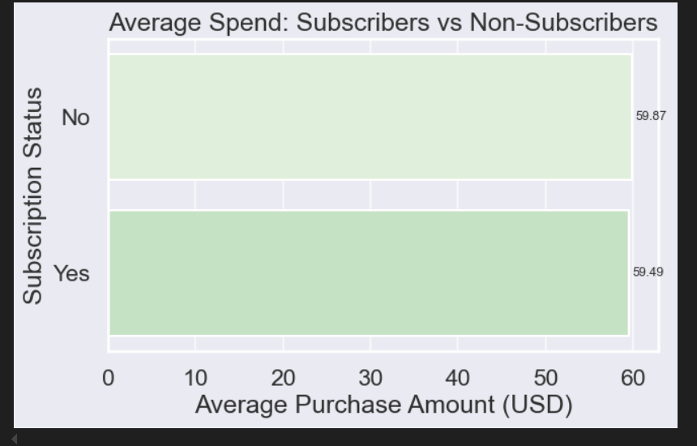
This chart compares the average purchase amount for subscribers and non-subscribers. Subscribed customers show a slightly higher average spend per purchase. Even a modest difference at the average level can translate into significant revenue impact at scale.
Business Insights
- Subscribed customers demonstrate higher per-purchase value.
- Subscription programs may attract less price-sensitive customers.
- Improving subscription adoption could increase average order value.
“Subscribed customers show higher average spend, indicating stronger per-customer value compared to non-subscribers.”

## Total Revenue by Subscription Status
Total revenue was compared between subscribed and non-subscribed customers
to understand which group contributes more to overall business performance.
A horizontal bar chart is used to clearly highlight differences in revenue
contribution across subscription segments.
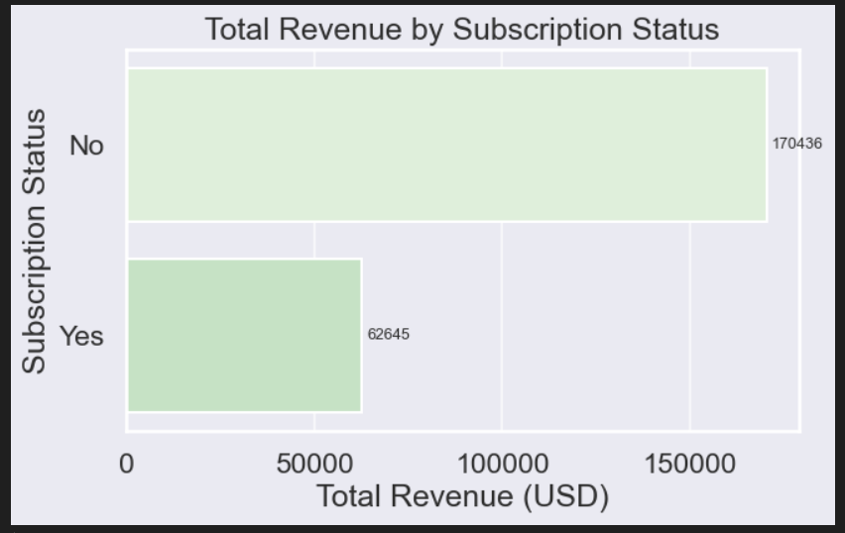
This chart shows the total revenue contribution by subscription status. Subscribed customers contribute significantly more total revenue than non-subscribers. This indicates that subscriptions are not only improving average spend but also driving overall business revenue.

Business Insights
- Subscribed customers are a major revenue driver for the business.
- Higher total revenue may result from a combination of higher spend and repeat purchases.
- Subscription programs appear to be effective in capturing high-value customers.
- Strengthening subscription acquisition and retention can have a direct impact on revenue growth.
“Subscribed customers generate a substantially higher share of total revenue, making subscriptions a key lever for revenue growth.”

## Customer Distribution by Subscription Status
To understand customer composition, the percentage of subscribed and
non-subscribed customers were calculated.
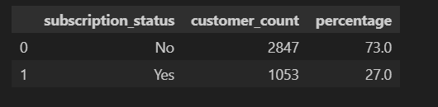
A donut chart is used to visualize how customers are distributed across
subscription status, making it easy to identify the dominant segment.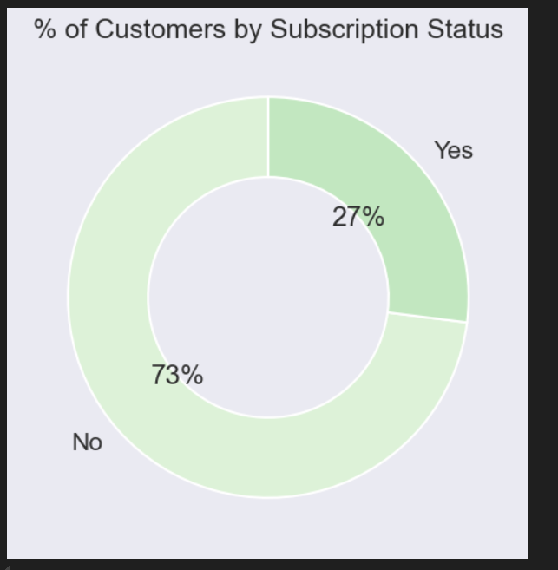
This chart shows the distribution of customers by subscription status. Currently, only about 27% of customers are subscribed, while 73% are not. This highlights a large opportunity to convert non-subscribed customers into subscribers.
Business Insights
- The majority of customers are not subscribed.
- Despite being a smaller group, subscribers contribute disproportionately high revenue (from previous analysis).
- There is strong potential to increase revenue by improving subscription adoption.
- Targeted campaigns for non-subscribers could significantly impact overall performance.
“I used a donut chart here because the goal was to show customer composition, where parts of a whole are best represented visually.”

## Top 5 Products with Highest Discount Purchase Percentage
The discount application rate was calculated for each product as the
percentage of purchases where a discount was applied.
The top five products with the highest discount rates were selected to
understand which items are most frequently sold under promotional pricing.
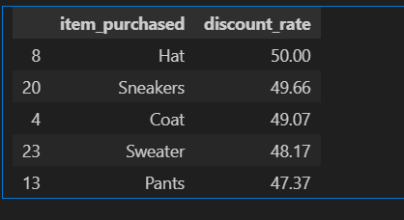
A lollipop chart is used as a clean alternative to a bar chart to clearly
rank products by discount dependency.

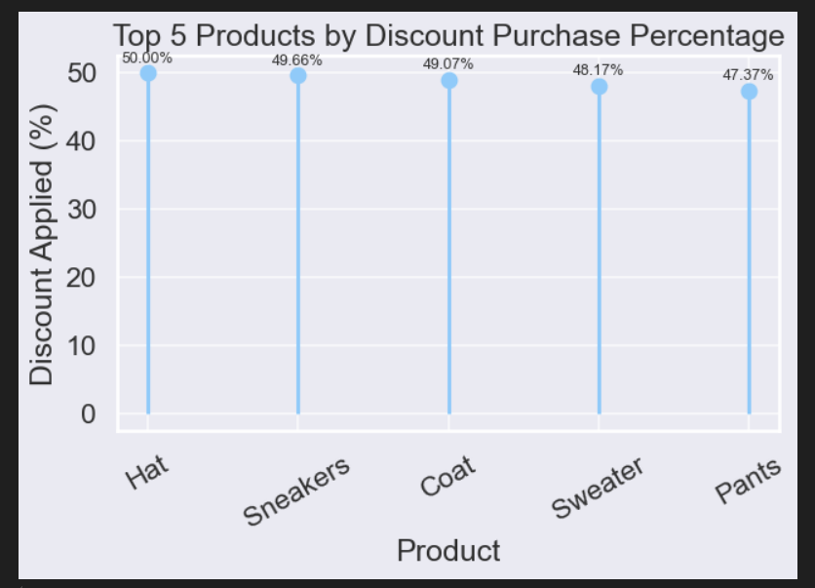
This chart highlights the products most frequently purchased with discounts. These items show a high dependency on promotional pricing. Customers may be price-sensitive for these products or expect discounts as standard. Discount strategy for these products should be carefully evaluated to protect margins.

Business Insights
- Certain products are heavily reliant on discounts to drive sales.
- High discount rates may indicate price sensitivity or intense competition.
- These products could be used as traffic drivers, but with controlled margins.
- Products with consistently high discount rates should be reviewed for pricing optimization.

“The top discounted products show strong dependence on promotional pricing, indicating potential price sensitivity and margin risk.”
## Customer Segmentation by Purchase History

Customers were segmented into New, Returning, and Loyal groups based on the
number of previous purchases.
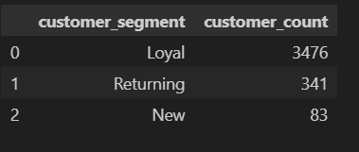
The treemap visualizes the proportion of customers in each segment, where larger areas represent higher customer counts. Colour intensity is used to highlight customer maturity, with darker shades indicating higher loyalty.
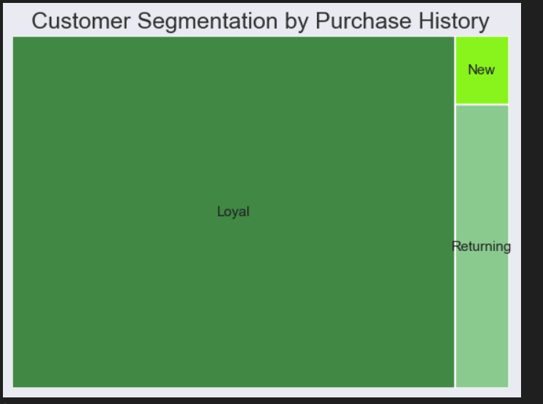

This treemap shows customer distribution across loyalty stages. Loyal customers make up the largest portion, highlighted by the darkest colour. Returning customers represent the strongest opportunity for upsell and retention. New customers are present but limited, indicating scope for improved acquisition
or onboarding strategies.

Business Insights
- Loyal customers dominate the customer base, indicating strong retention.
- Returning customers form a meaningful middle layer, representing the key
conversion opportunity into loyalty.
- New customers exist but represent a small share, suggesting limited recent
acquisition or a retention-focused dataset.
- Business growth can be driven by:
  - Converting returning → loyal customers
  - Improving onboarding and early engagement for new customers

“The customer base is retention-heavy, with loyal customers dominating, while new customers form a small but critical acquisition pipeline.”

“Which customer segments drive purchases across different product categories?”
## Purchase Intensity by Customer Segment and Category

A heatmap is used to analyze how different customer segments contribute to
purchases across product categories.
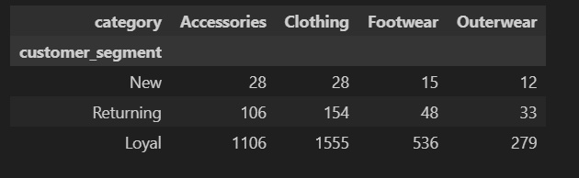

This visualization highlights behavioral patterns by showing purchase intensity
at the intersection of customer loyalty and product category.
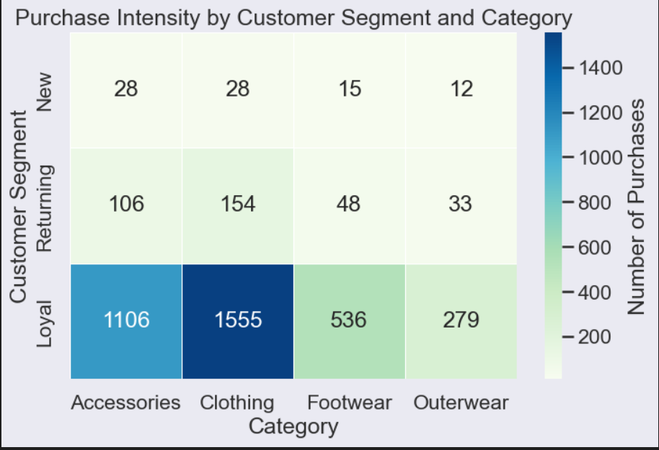
This heatmap shows purchase intensity across customer segments and product categories. Darker cells indicate higher purchase activity. Loyal customers dominate purchases across all categories, especially Clothing and Accessories. New customers show very limited activity, mainly concentrated in Accessories and Clothing.
Business Insights
- Loyal customers are the primary revenue drivers, accounting for the majority of purchases in every category.
- Clothing is the strongest category, particularly among loyal customers, indicating repeat demand.
- Returning customers show moderate engagement, suggesting a strong conversion opportunity into loyalty.
- New customers contribute minimally, highlighting a need for better onboarding and activation strategies.

“Purchases are overwhelmingly driven by loyal customers, with Clothing emerging as the strongest category across all segments.”

Purchase Intensity Across Customer Journey:
How purchase activity increases as customers move from New → Returning → Loyal, broken down by category.

## Purchase Intensity Across Customer Journey
A line chart is used to analyse how purchase activity evolves as customers move through different loyalty stages: New, Returning, and Loyal.
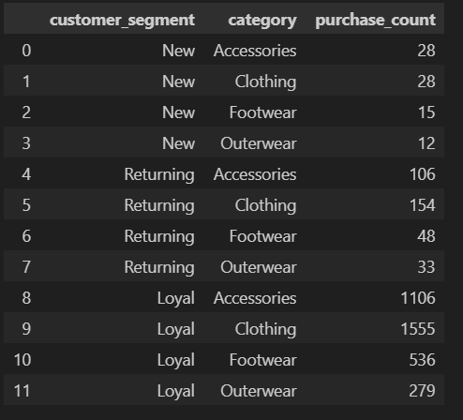
Each line represents a product category, allowing comparison of growth patterns across the customer lifecycle. This visualization highlights how customer value increases with retention rather than acquisition alone.
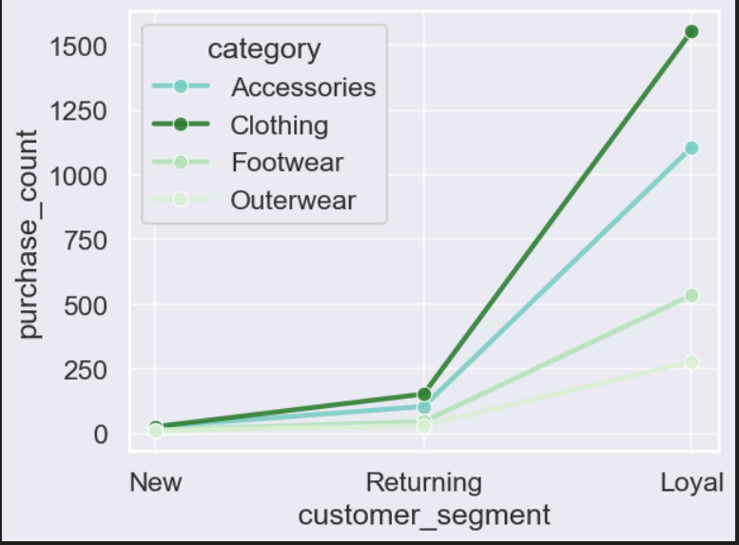
This line chart shows how purchase activity changes as customers move from New to Returning to Loyal. Each line represents a product category, allowing comparison across the customer journey. Purchase intensity increases sharply at the Loyal stage, especially for Clothing and Accessories. This demonstrates how customer value compounds with retention rather than acquisition alone.
Business Insights
- Loyal customers drive the majority of purchases across all categories.
- Clothing shows the steepest growth, indicating strong repeat demand and brand affinity.
- Accessories also scale significantly with loyalty, making them effective for upsell and bundling.
- New customers exhibit limited engagement, highlighting the need for strong onboarding and early incentives.
- Retention-focused strategies are likely to yield higher ROI than acquisition-only efforts.

“Purchase activity accelerates dramatically as customers become loyal, with Clothing and Accessories benefiting the most from retention.”

“Do customers using different payment methods purchase more frequently or less frequently?”
## Purchase Frequency by Payment Method
This analysis examines whether customers using different payment methods exhibit different purchase frequency patterns. Purchase frequency is measured as the number of days between purchases.
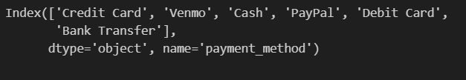
A stacked histogram is used to visualize the distribution of purchase frequency
across payment methods, allowing comparison of how often customers return
based on their preferred payment option.
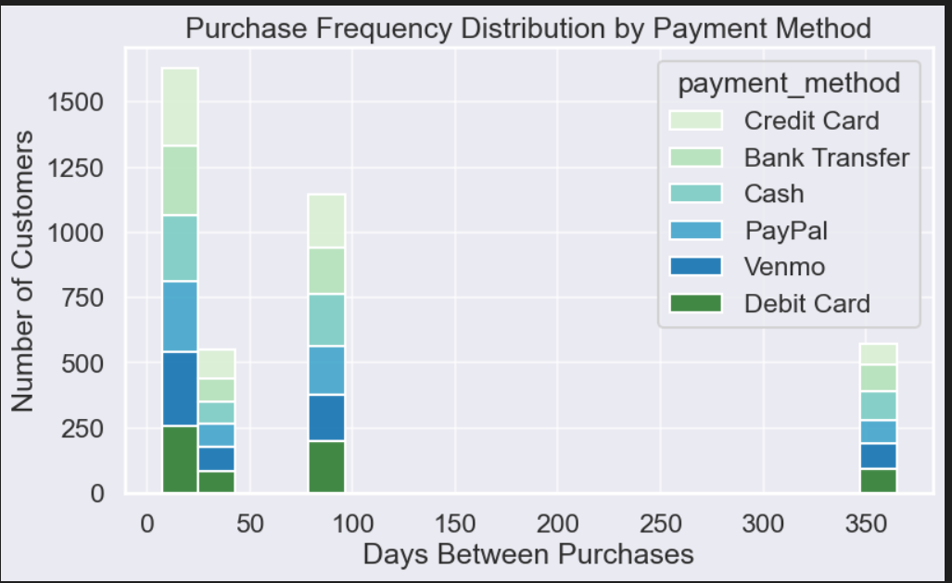
This stacked histogram shows how purchase frequency is distributed across customers, segmented by payment method. Each bar represents a range of days between purchases, with colours indicating the contribution of different payment methods. Shorter intervals indicate more frequent purchases, while longer intervals represent infrequent buyers. This view helps compare how payment methods influence customer purchasing behaviour within the same frequency ranges.

Business Insights
- Most purchases occur within shorter intervals, indicating a strong base of frequent buyers across payment methods.
- Digital payment methods (Credit Card, PayPal, Venmo) dominate the high-frequency purchase ranges, suggesting higher engagement.
- Cash and bank transfer users appear more concentrated in longer purchase intervals, indicating less frequent buying behaviour.
- Payment convenience is likely a key driver of repeat purchasing and customer retention.

“Customers using digital payment methods tend to purchase more frequently, while traditional payment methods show longer gaps between purchases.”

“How does average spending vary across different age groups?”

## Average Purchase Amount by Age Group
Customers were segmented into four age groups to simplify analysis and reduce noise from individual transactions.
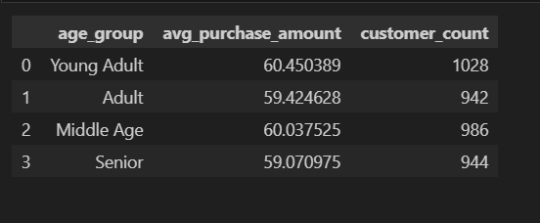

A bubble chart is used to compare the average purchase amount across age groups, where larger bubbles represent higher average spending. This approach highlights spending differences in a clear and interpretable way.

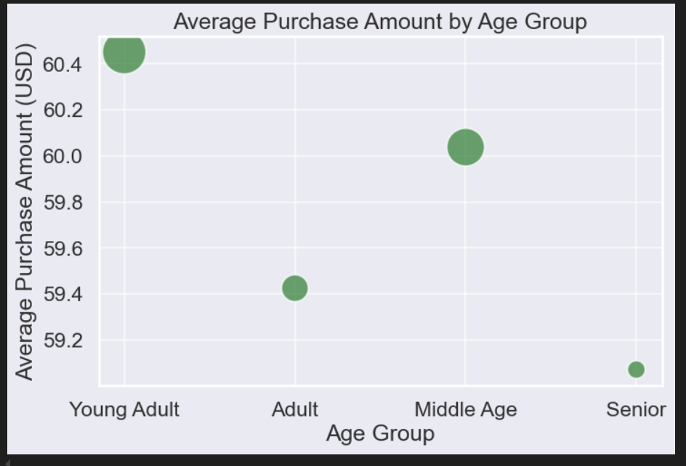
Individual transaction-level analysis was noisy and hard to interpret. Customers were grouped into four age segments for clarity. This visualization compares average spend per transaction across age groups. Bubble size reinforces relative spending differences, making comparison intuitive. Differences are present but not extreme, indicating broadly similar spending behavior across ages.
Business Insights
- Young Adults show the highest average purchase amount, but the margin is small.
- Middle-aged customers also demonstrate slightly higher spending consistency.
- Senior customers have the lowest average spend per transaction.
- Overall, age is not a strong driver of spending, suggesting pricing works across age groups.

“Average purchase value is fairly consistent across age groups, with only minor variation, indicating age is not a primary driver of spending behavior.”

